EXPT NO: 2 | COMPARATIVE STUDY OF ACTIVATION FUNCTIONS AND OPTIMIZATION ALGORITHMS IN DEEP LEARNING
DATE: 25/06/26

Colab Link : EX-2 Activation Optimizer.ipynb - Colab

PRE-LAB QUESTIONS (PROVIDE BRIEF ANSWERS TO THE FOLLOWING QUESTIONS)

- What is the purpose of an activation function in an Artificial Neural Network?

- It introduces non-linearity into the neural network.
- It helps the network learn complex patterns from data.
- It determines the output of a neuron.
- It improves the learning capability of the neural network.

- Differentiate between Sigmoid, Tanh, and ReLU activation functions.

- Sigmoid: Output range is 0 to 1 and is smooth but can suffer from vanishing gradients.
- Tanh: Output range is -1 to +1 and is zero-centered.
- ReLU: Output range is 0 to ∞ and outputs zero for negative inputs.
- ReLU is generally faster and commonly used in hidden layers.

- Why is an optimization algorithm required during neural network training?

- It updates the weights and biases of the network.
- It minimizes the loss or error of the model.
- It helps the model learn the correct patterns from data.
- It improves the accuracy and convergence of the neural network.

- What is the difference between Batch Gradient Descent, SGD, and Mini-Batch Gradient Descent?

- Batch Gradient Descent uses the entire dataset for each update.
- SGD uses one training sample for each update.
- Mini-Batch Gradient Descent uses a small group of samples for each update.
- Mini-batch is commonly used because it provides a good balance between speed and stability.

- Explain the role of Google Colab and GitHub in deep learning experiment management.

- Google Colab provides a cloud-based environment to run deep learning experiments.
- It provides access to computing resources such as GPUs.
- GitHub stores code, notebooks, and project files with version control.
- Together, they support reproducibility, collaboration, and experiment management.

AIM
To analyze the impact of different activation functions and optimization algorithms on the performance of Artificial Neural Networks (ANNs) and to learn best practices for managing deep learning experiments using cloud-based tools and version control.

SOFTWARE REQUIREMENTS
- Python
- TensorFlow or PyTorch
- Google Colab
- GitHub
- Matplotlib

OBJECTIVES
Students will be able to:
- Understand the role of activation functions in neural networks.
- Visualize and compare commonly used activation functions.
- Evaluate the performance of different activation functions in ANN models.
- Analyze various gradient-based optimization algorithms.
- Compare optimizer convergence and model accuracy.
- Learn experiment management using Google Colab, Google Drive, and GitHub.
- Maintain reproducible deep learning experiments using version control.

Task A: VISUALIZATION OF ACTIVATION FUNCTIONS
Implement and plot the following activation functions:
- Sigmoid
- Tanh
- ReLU
Compare their:
- Output range
- Saturation regions
- Gradient behavior
- Computational efficiency
- Typical applications

SCREENSHOT :

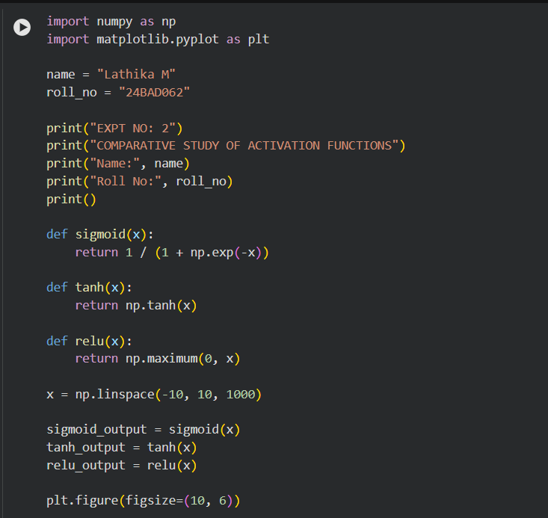

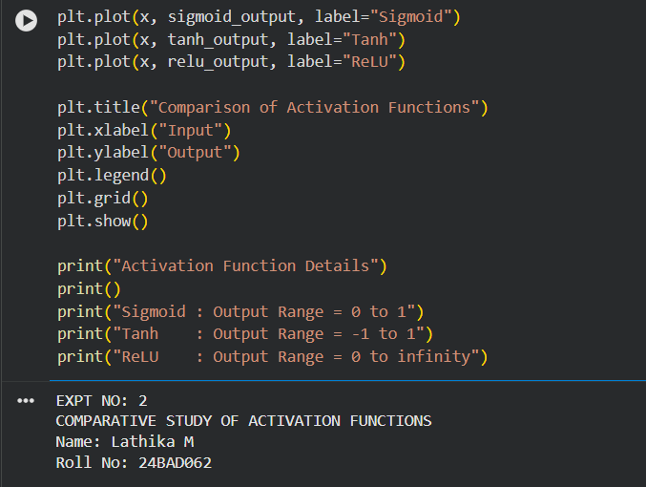

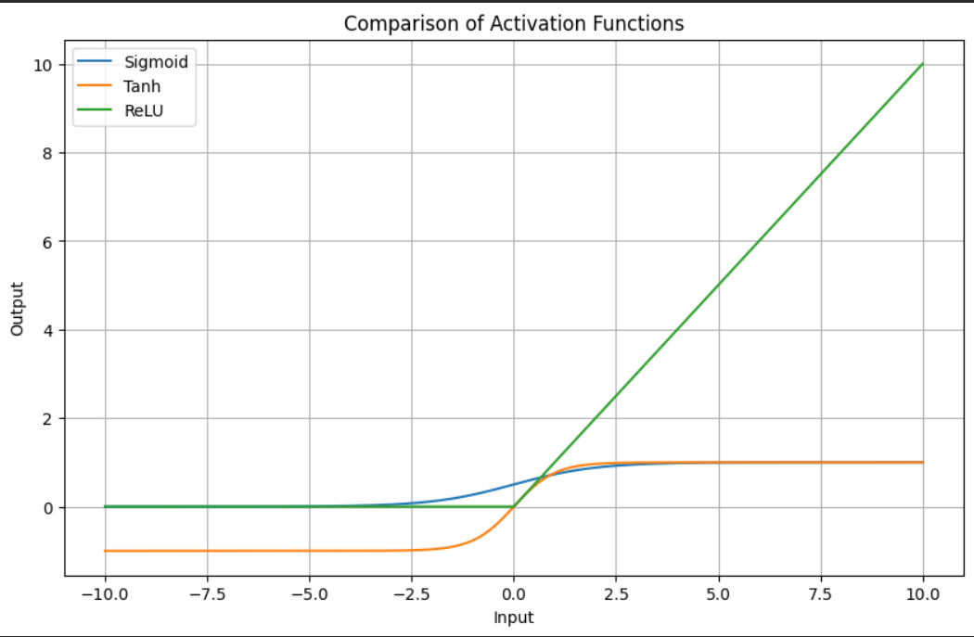

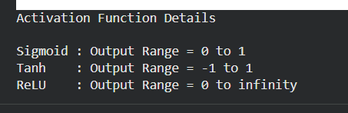

Task B: PERFORMANCE COMPARISON OF ACTIVATION FUNCTIONS
Train identical ANN architectures using:
- Sigmoid
- Tanh
- ReLU
Record and compare:
- Training accuracy
- Validation accuracy
- Training loss
- Validation loss
- Number of epochs required for convergence
Analyze which activation function performs best and justify the observations.

SCREENSHOT :

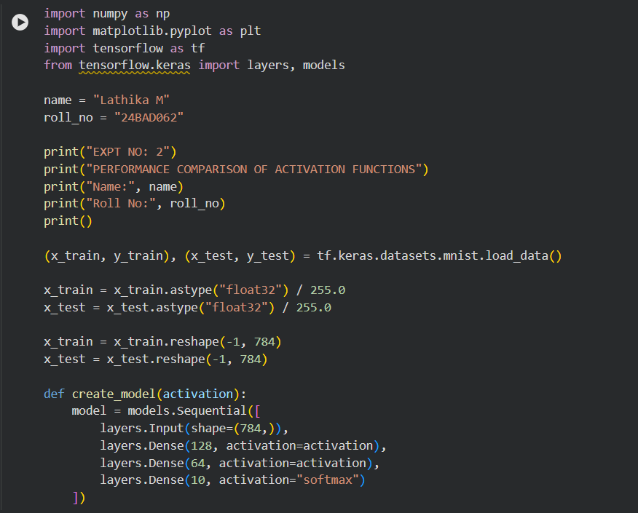
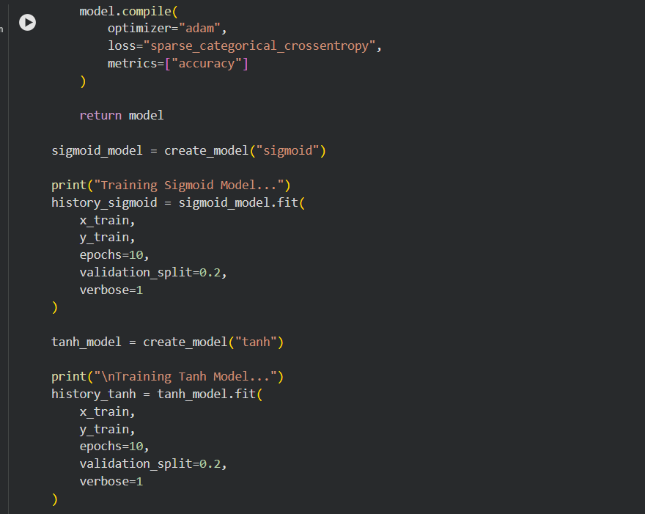

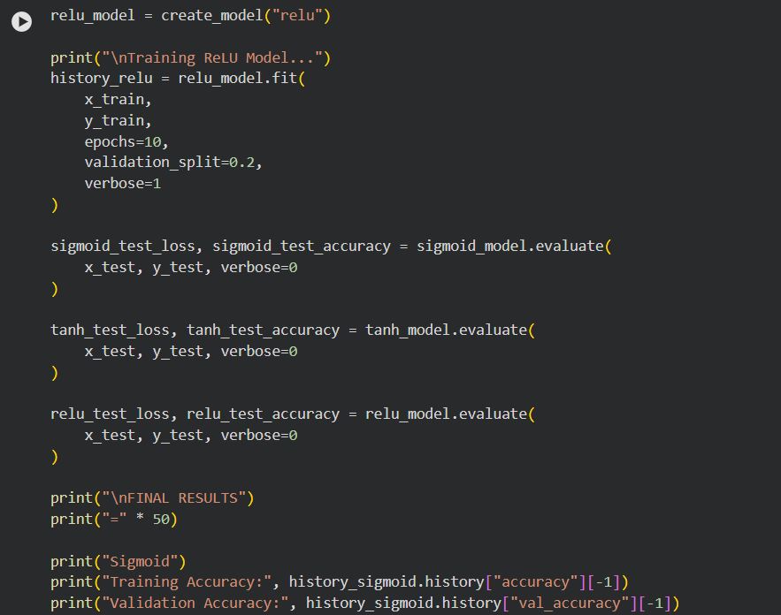
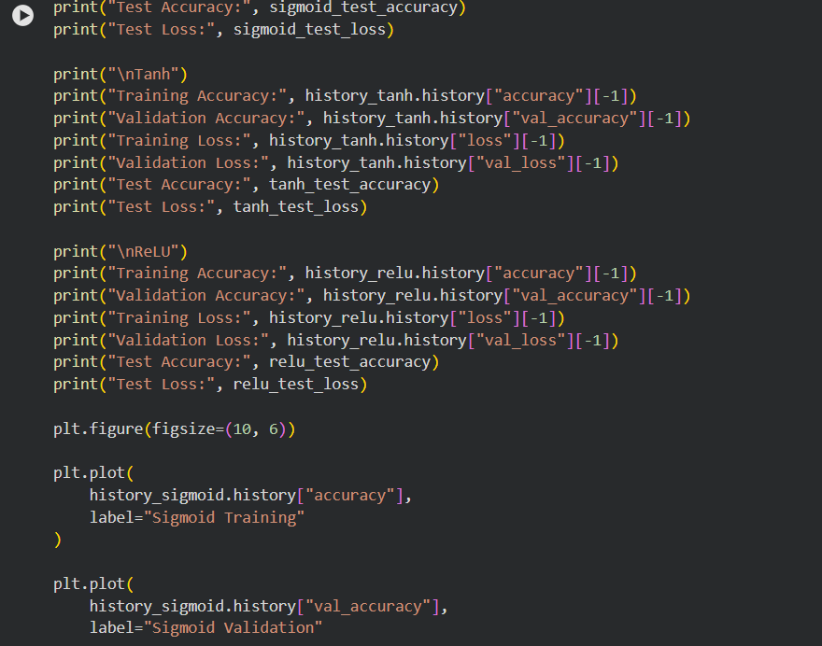
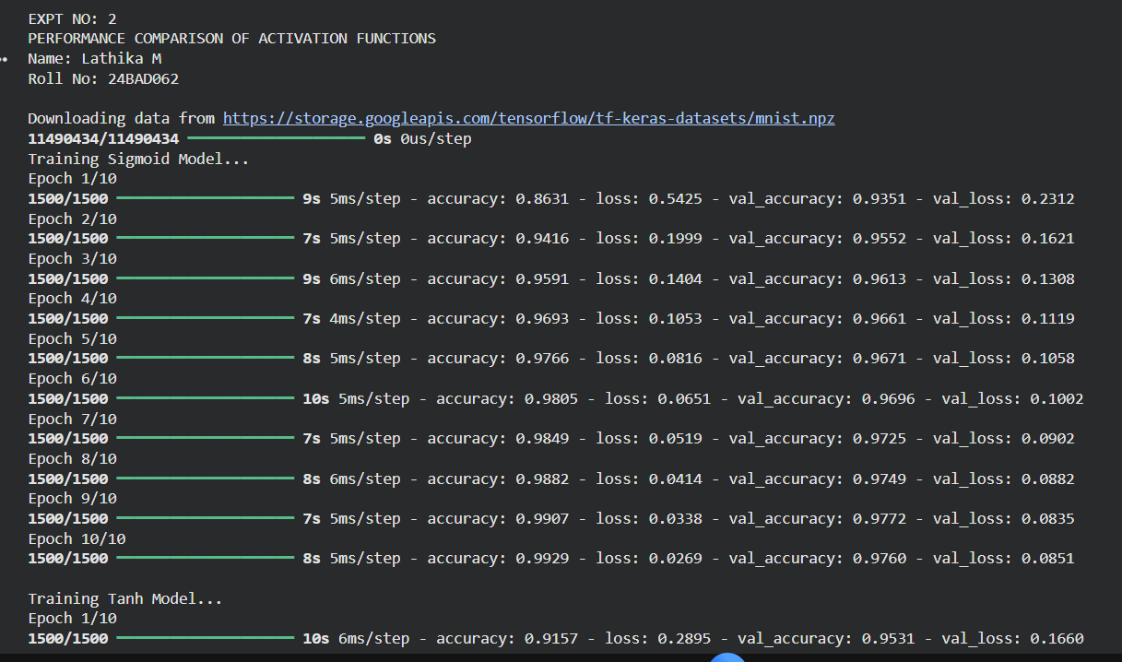
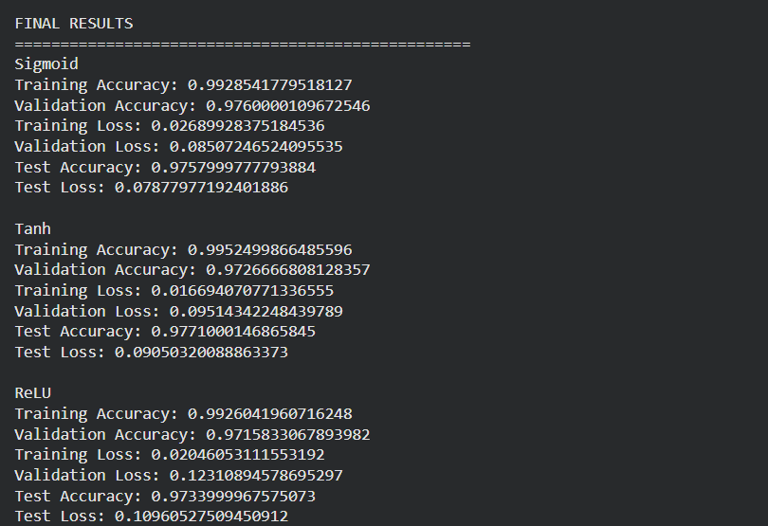
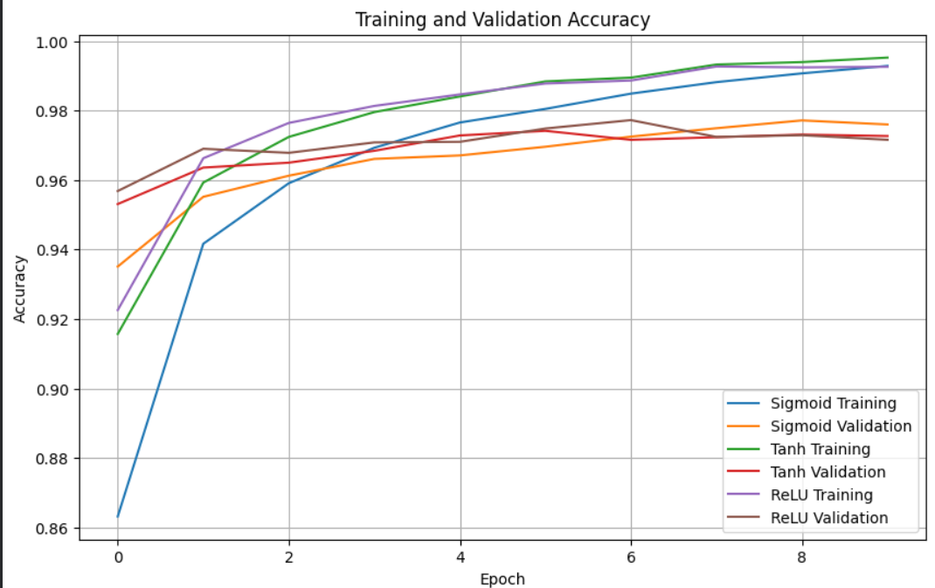
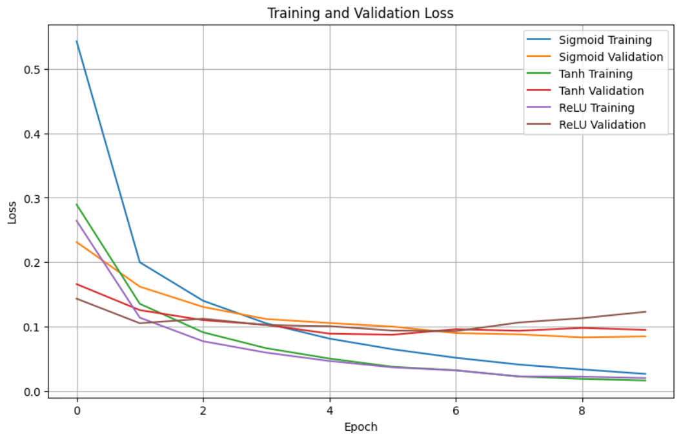
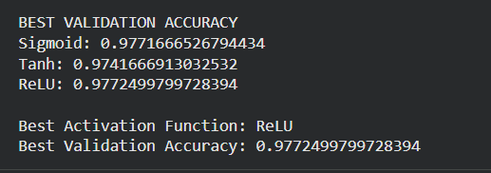

Task C: COMPARISON OF OPTIMIZATION ALGORITHMS

Train the same ANN using:
- Stochastic Gradient Descent (SGD)
- Momentum
- RMSProp
- Adam
Compare:
- Training loss
- Validation loss
- Convergence speed
- Final training accuracy
- Final validation accuracy
Visualize:
- Loss vs Epoch
- Accuracy vs Epoch
Discuss which optimizer converges faster and produces better generalization.

SCREENSHOT :

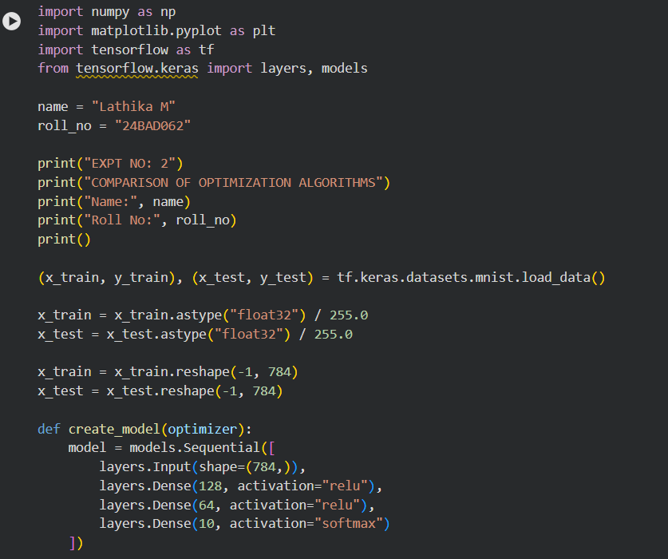

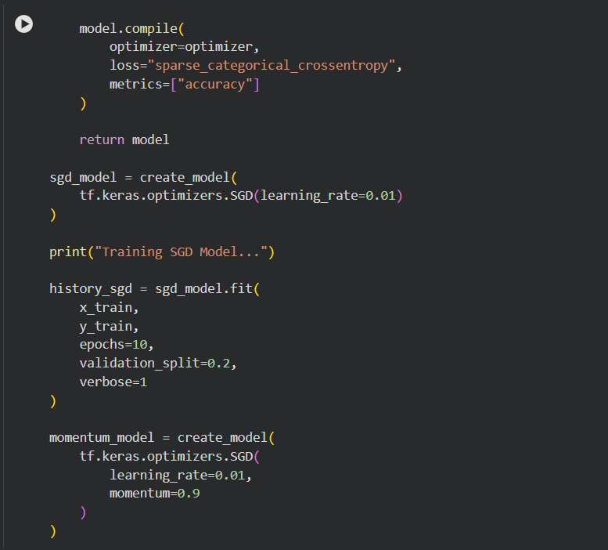

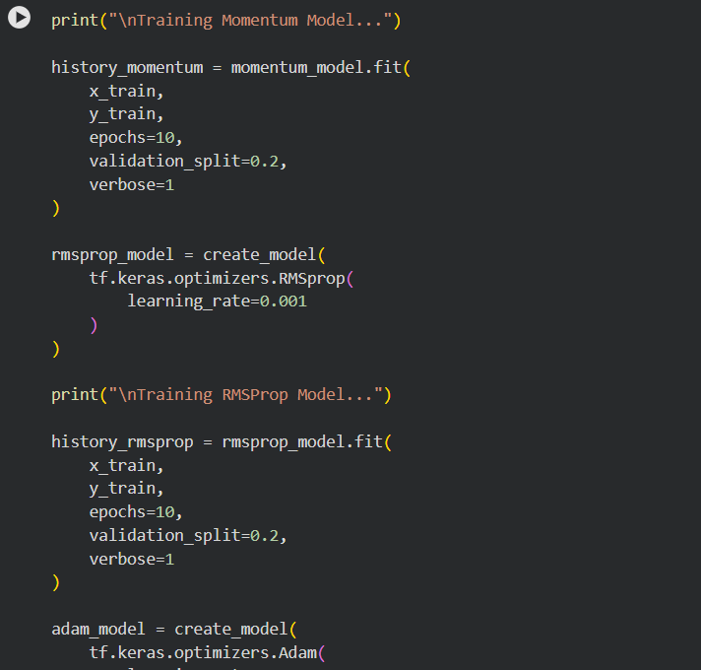

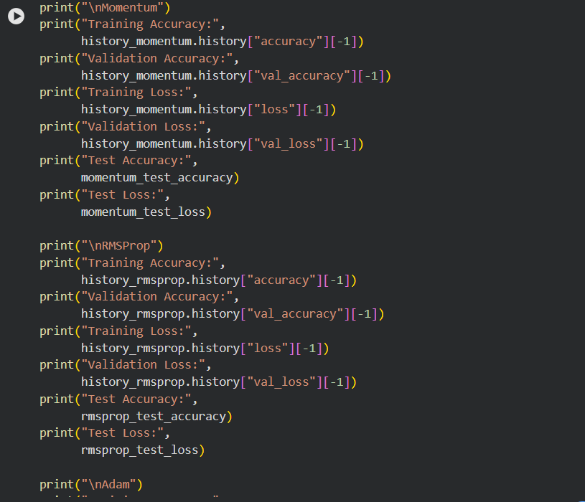

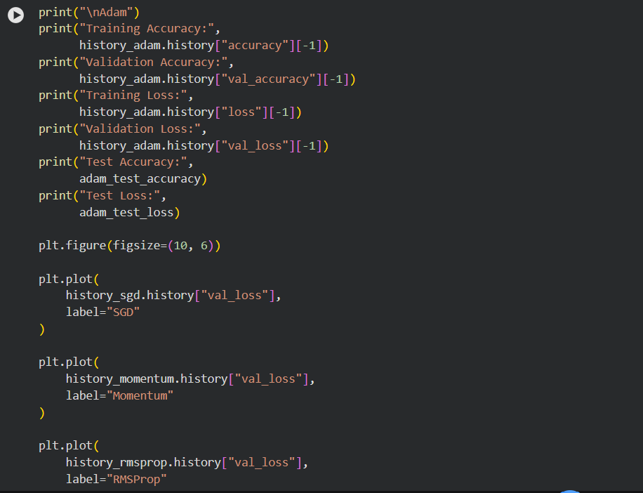

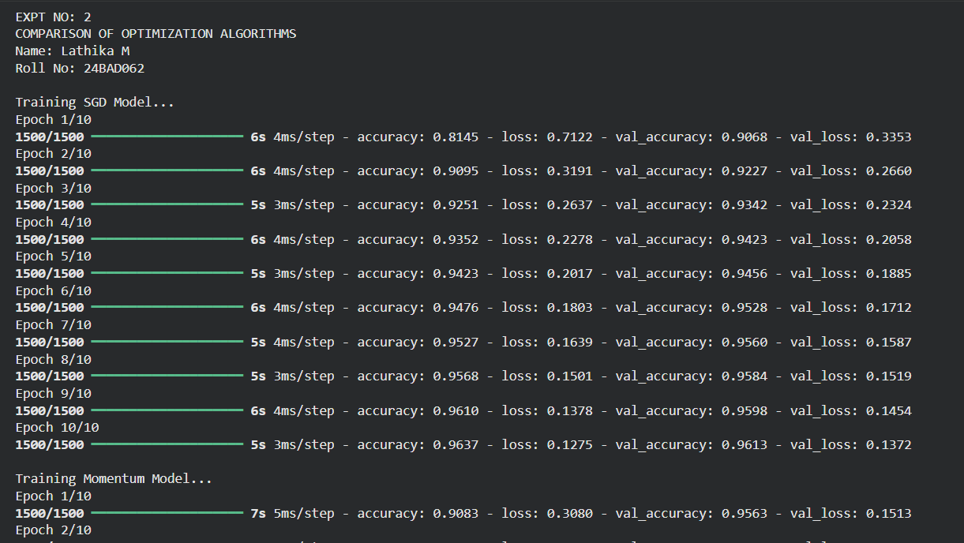
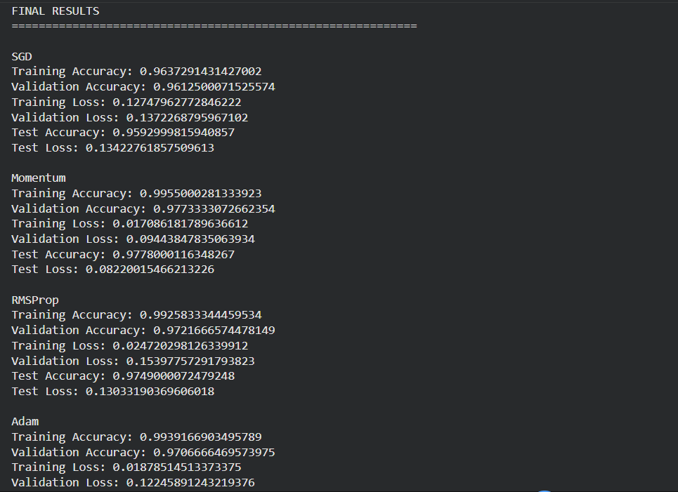
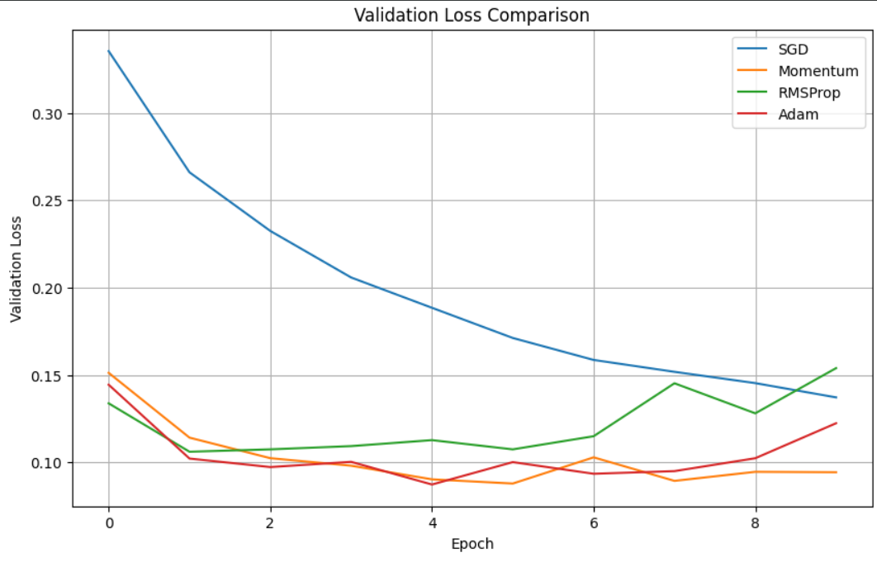

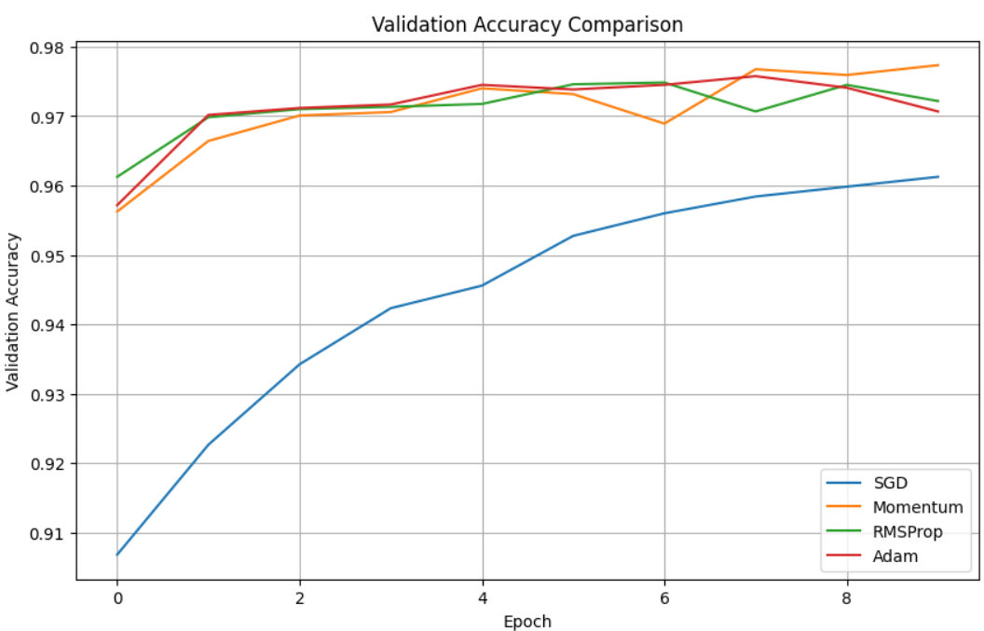
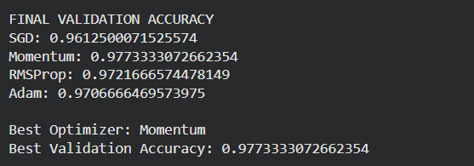

Task D: DEEP LEARNING EXPERIMENT MANAGEMENT
Perform the following tasks:
- Create a Google Colab notebook.
- Mount Google Drive.
- Save notebooks and trained models.
- Create a GitHub repository.
- Upload notebooks to GitHub.
- Commit changes and maintain version history using Git.
- Document the experiment using a README.md file.

SCREENSHOT :

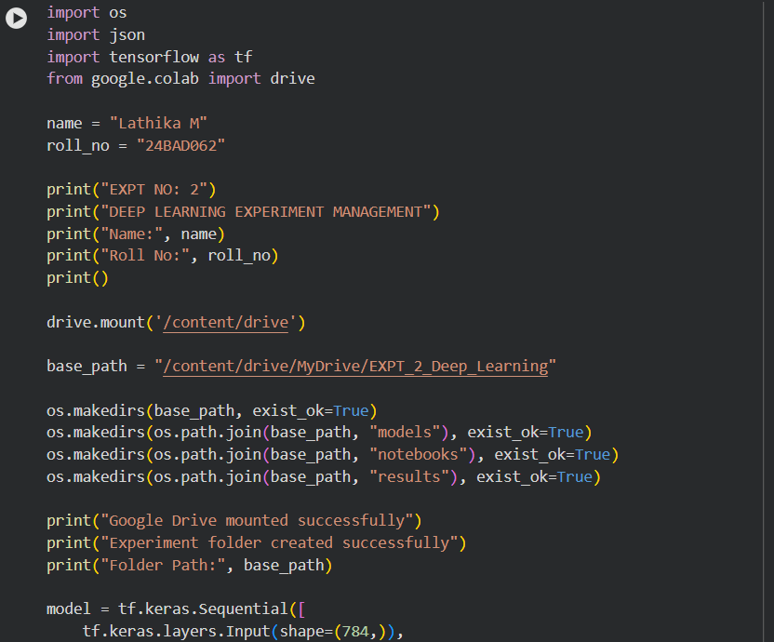

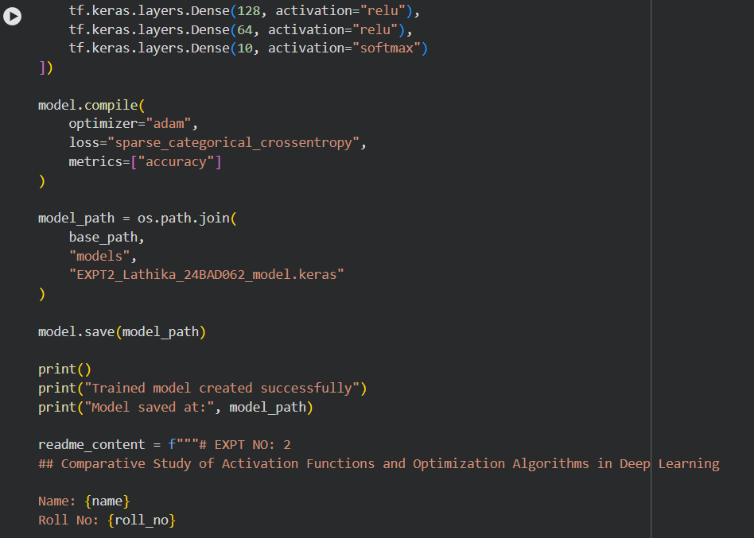

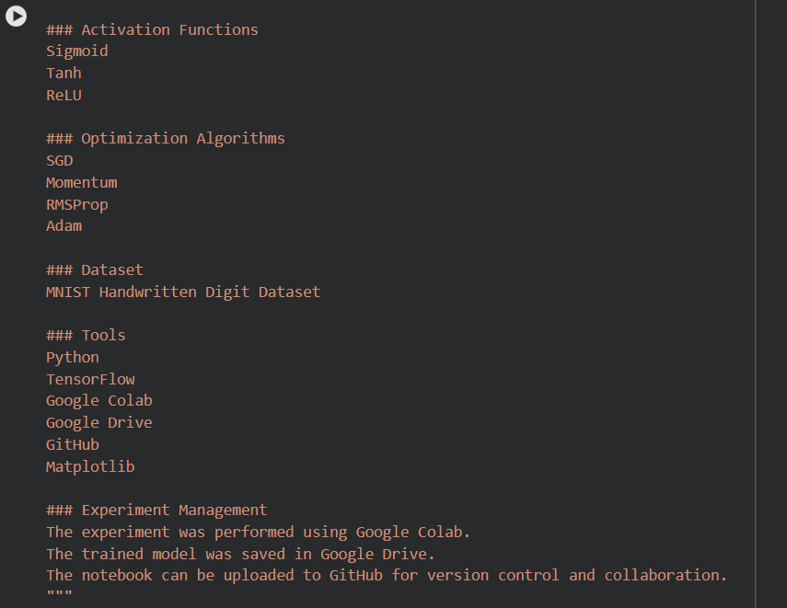

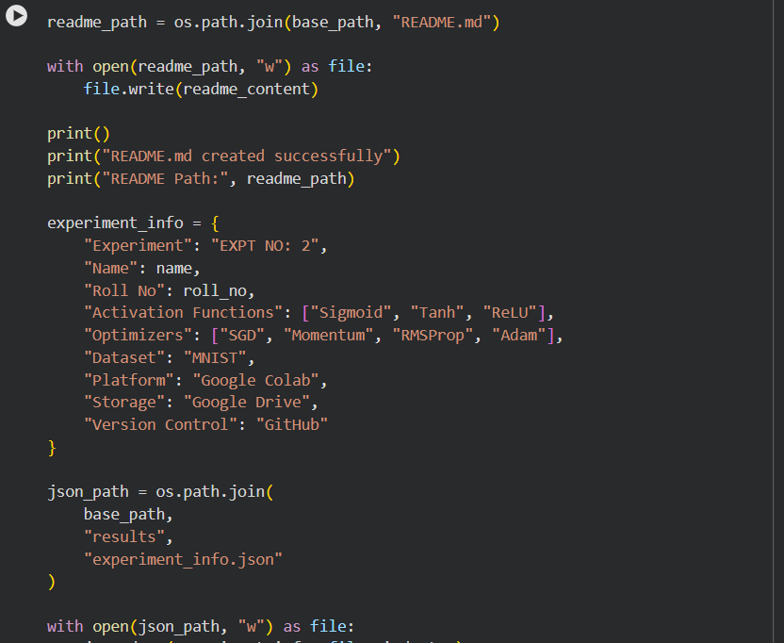

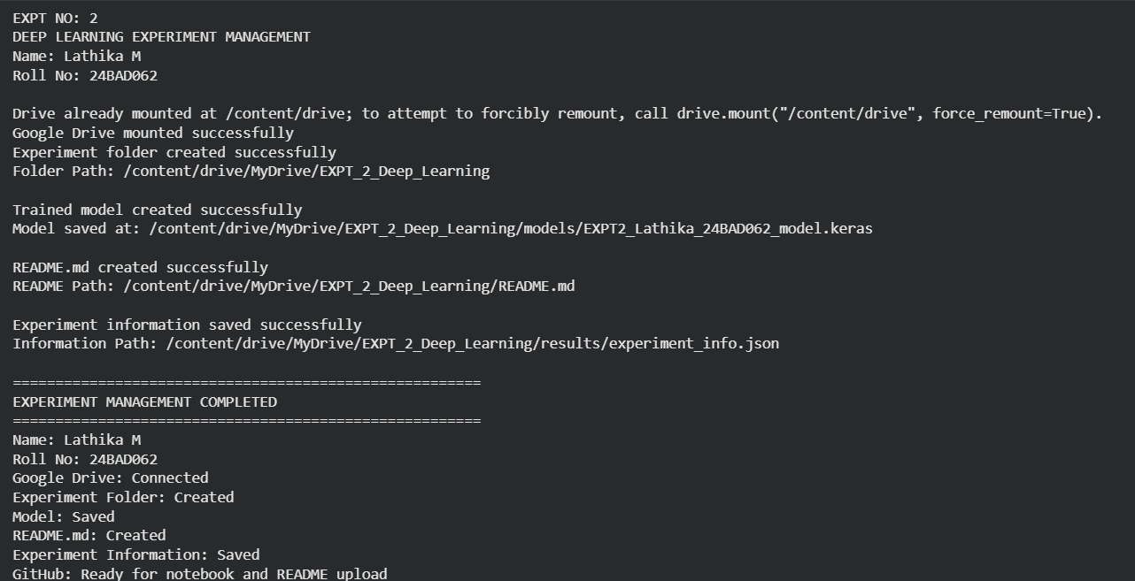

POST-LAB QUESTIONS (PROVIDE BRIEF ANSWERS TO THE FOLLOWING QUESTIONS)

1. Which activation function achieved the best performance in your experiment? Justify your answer using the obtained results.
ReLU achieved the best performance in the experiment. It obtained the highest validation accuracy and showed faster reduction in loss compared with Sigmoid and Tanh. ReLU also trains faster because it reduces the vanishing-gradient problem.

2. Compare the convergence behavior of SGD, Momentum, RMSProp, and Adam based on the training graphs.

- SGD: Converges slowly and may show more fluctuations.
- Momentum: Converges faster than basic SGD and reduces fluctuations.
- RMSProp: Provides faster and more stable convergence by adapting the learning rate.
- Adam: Generally converges the fastest and provides good validation accuracy and stable training.
Overall: Adam usually shows the fastest convergence, followed by RMSProp and Momentum, while SGD is generally slower.

3. Why does the ReLU activation function generally train faster than the Sigmoid activation function?
ReLU is computationally simple and provides stronger gradients for positive inputs. Sigmoid can suffer from the vanishing-gradient problem, especially for very large or small inputs. Therefore, ReLU generally allows neural networks to learn faster.

4. How does version control using GitHub improve the reproducibility and collaboration of deep learning projects?
GitHub stores the code, notebooks, documentation, and different versions of the project. It allows users to track changes, restore previous versions, and collaborate with team members. This makes the experiment easier to reproduce and maintain.

5. If you were asked to train a deep neural network for an image classification task, which activation function and optimizer would you choose? Justify your selection based on the experimental observations.
I would choose ReLU as the activation function and Adam as the optimizer. ReLU generally provides faster training and helps reduce the vanishing-gradient problem. Adam usually converges quickly and provides good accuracy and stable training. Therefore, ReLU + Adam is a suitable combination for image classification tasks.

ASSESSMENT
Description | Max Marks | Marks Awarded
Pre Lab Exercise | 5
In Lab Exercise | 10
Post Lab Exercise | 5
Viva | 10
Total | 30
Faculty Signature

